Three Semester Review
After three semesters in the Media, Self, and Society Scholars program, I can confidently say that this program its perfectly captured by its full title. Through my time in the community, I was given the opportunity to learn about my specific media consumption and how it affects me, as well as how others in society view media. I believe media’s role is largest it has ever been in our society. With an election just recently behind us, we were given a huge event to analyze through the eyes of a media scholar. A presidential election takes media to a new level, reaching out to individuals on all social media platforms. I had never seen the amount of content pushing for Americans to vote as I did this past year. Whether it be because this was my first time being aware, given I had never participated in an election before, or since we are living in a time of great technological innovation, there is no doubt that media content played a huge role in this past election. This was an exciting time to be a media scholar. Not only was I aware of the rise in political content, but I was able to analyze the role it had within society through Media, Self, and Society courses. We studied what types of advertisements are more effective on an audience, which really opened my eyes to how much goes into creating an effective ad.
Through this program, I have had many chances to employ critical analysis to all types of media. The most recent example of this was when I created a short podcast with two other Media Scholar students to discuss racial stereotypes through media. My friends and I came together to watch the movie “Crazy Rich Asians” and then engaged in a thoughtful conversation. While we did organize this event for academic reasons, it sparked casual conversations among my group of friends about how common readdressing racial and gender stereotypes is in the movie industry in the recent past. My time in media has prepared me for these types of conversations in allowing me to see multiple perspectives to every situation, and being able to analyze the deeper meaning behind what may seem to be a surface level image or symbol.
In this past election, we saw countless cases of “fake news.” This can be harmful to our society, as it spreads false information across a wide platform. When voters are consuming information that it not fully true, it allows them to form opinions on important topics without being fully informed what the full story is. Luckily for us, as the levels of fake news rose, so did the levels of fact checking sources. Instagram, Twitter, and Facebook all added disclaimers to any post that they felt may include false or not entirely true information. With sources like these, we as a society are able to form educated opinions and make decisions in the best way possible. Knowing all the facts in important when choosing a Presidential candidate to support, and due to the increase in fact checking resources, we were able to do just that.
In my opinion being a critical consumer and producer of media means actively engaging and analyzing the media content you come in contact with. A passive consumer would be exemplified by an individual who mindlessly consumes content without ever stopping to find out more information, such as where the content is coming from, who is the targeted audience, etc. I believe that I take on both roles depending on the situation. As a Media Scholar, I have become aware how important it is to really think about the media content you are interacting with. With this being said, the amount of media consumption a typical college student faces, it can become tiring to constantly analyze ever post and story you see online.
Being in Scholars introduced me to a variety of new people. Some of my best friends were originally my Scholars classmates. Discussing how I have had my own beliefs challenged through meeting new people is challenging to talk about because I feel that it is a part of my daily life without even noticing when it happens. Whenever I meet new people and learn more about them and their beliefs, I find myself reflecting on my personal opinions. I do believe the people that I have met through the Scholars program have given me so much more than I even know, given that they have slowly shaped me into the current version of myself.
Being a part of a living-learning community is a great opportunity to have. Taking a class together originally gives you a point of conversation with the people living near you, but it quickly shifts into much more. You find yourself creating deep and personal bonds to the people that live down the hall from you. It makes going to class that much more exciting, knowing it is a time to see familiar faces in a space that feels comfortable. Creating these bonds and having these people in my life also helped me academically. Having peers taking the same courses as you serve almost as a support system, for at the end of the day you know you are not going through what feels like a million assignments alone.
I had numerous opportunities to be involved and contribute to the Media Program. One example is the field trip we took to the African American Museum of History in Washington D.C. This trip was a great way to learn about African American history, but also to interact and get to know more of my peers. The out of classroom events always felt more casual to me. Another example of my involvement in the program is through Scholars Peer Mentors. I am currently a peer mentor for a few freshmen in the Media Scholars Program. I feel that this position has helped me stay connected to the program, especially in these challenging times. I do feel that COVID-19 took a large amount of opportunities for my peers and I to stay involved in our program. I believe that without this pandemic, everyone would be able to stay connected to the program in a much easier way.
Looking back on my time in this program, its hard to say where it may lead me. I am a Public Health Science major, so I am not sure if media will be a huge part of my future, but I am glad I had the chance to learn more about topics outside the public health field. I am sure I will continue to use methods in analyzing media that I learned through this course in my future. Social media plays a huge role in our society and I am well informed on this due to my time as a media scholar.

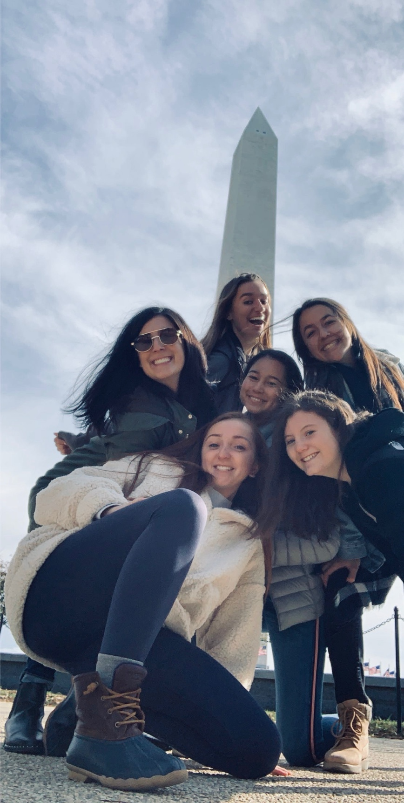
This picture was taken in Washington D.C. after our Media Scholars trip to the African American Museum of History. (pre COVID)

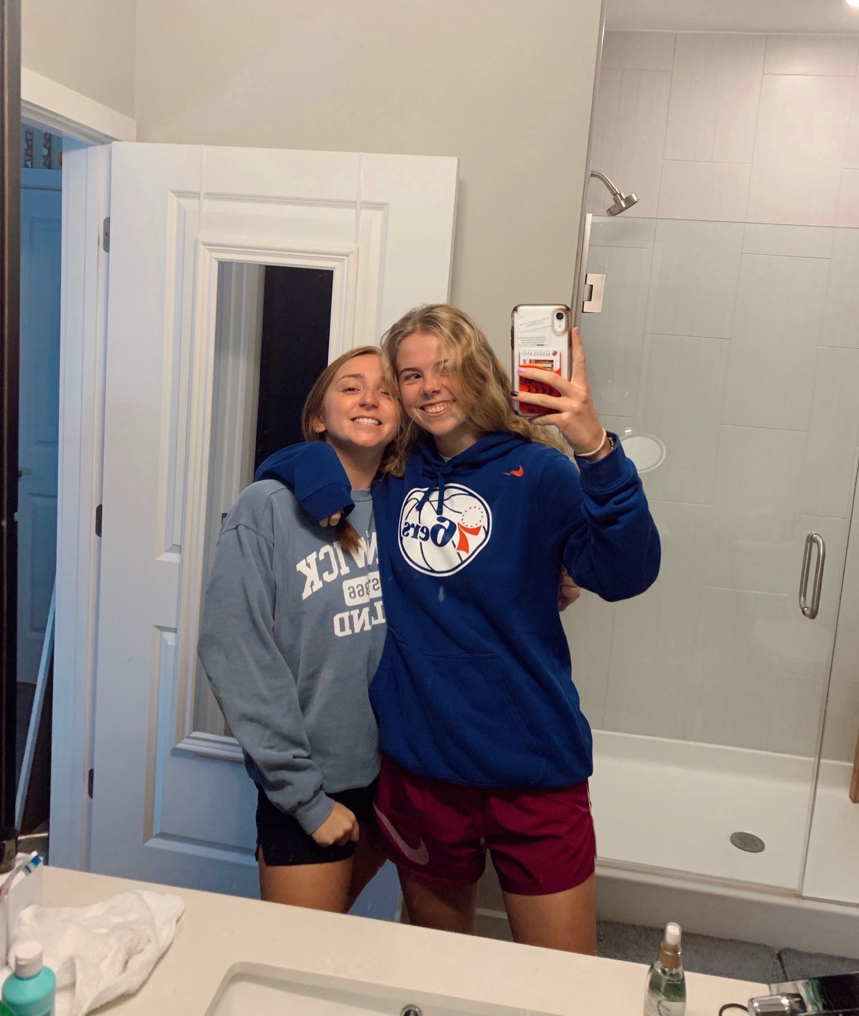
My current roommate (apart of International Studies Scholars) and I in our off campus apartment.

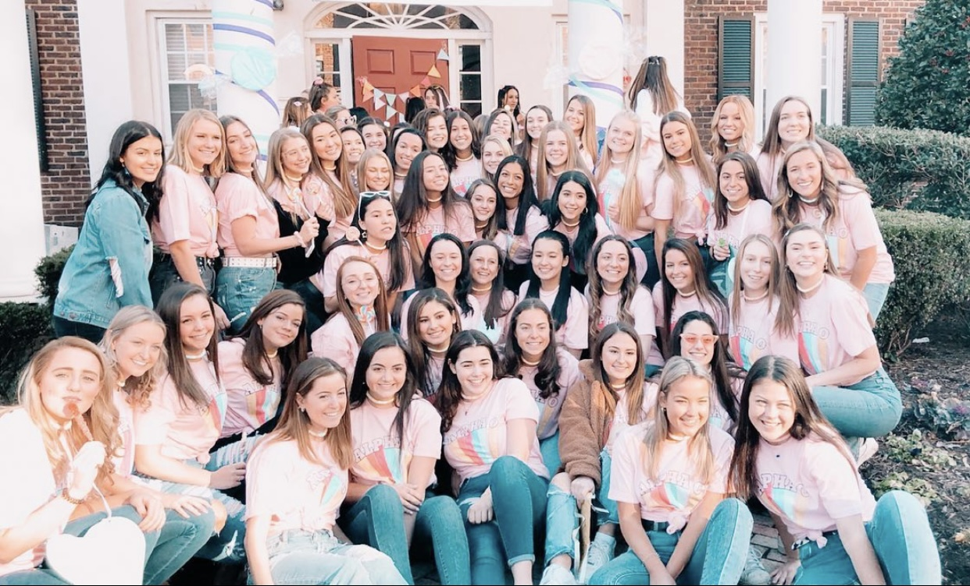
My pledge class on Bid Day in the spring. (pre- COVID)

